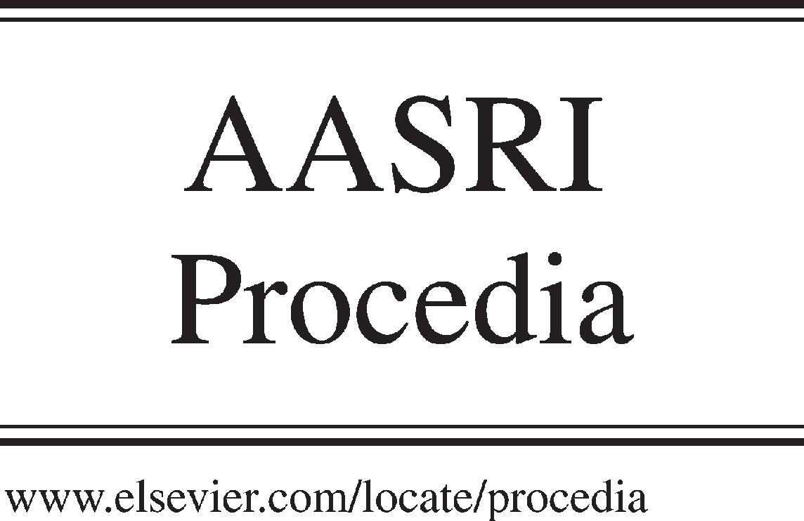Available online at [www.sciencedirect.com](http://www.sciencedirect.com/)



AASRI Procedia 3 (2012) 601 – 606

# 2012 AASRI Conference on Modelling, Identification and Control

Synthesis and Characterization of Water Soluble and Water Swelling Thermo-sensitive Copolymers based on 2- Hydroxyethylacrylate and 2-Hydroxyethylmethacrylate

G.A. Mun*, B.B.Yermukhambetova, P.I.Urkimbayeva, R.B. Bakytbekov,

G.S. Irmukhametova, R.A.Mangazbayeva, I.E.Suleimenov

*al-Faraby Kazakh National University, al-Farabi av., 71, Almaty, 050038, Kazakhstan*

Abstract

Thermo-sensitive linear and cross-linked copolymers based on 2-hydroxyethylacrylate and 2-hydroxyethylmethacrylate were synthesized and their physicochemical properties were investigated. It was found that copolymer solutions have lower critical solution temperature (LCST) and copolymer hydrogels of certain composition undergoes sharp collapse at temperature increase. The interaction of copolymers with surfactants was studied. It was shown that swelling behavior of copolymers in surfactants aqueous solutions depend on several factors: copolymer composition, surfactant concentration. Its influence on copolymer hydrogels is discussed. Great enhancing of amplitude of thermo-induce collapse of cross-linked polymers are caused by interaction of some nonionic hydrogels with ionic surfactant in aqueous solutions.

© 2012 The Authors. Published by Elsevier B.V. Open access under [CC BY-NC-ND license.](http://creativecommons.org/licenses/by-nc-nd/3.0/)

© 2012 G.A. Mun, B.B.Yermukhambetova, P.I.Urkimbayeva, R.B. Bakytbekov, G.S. Irmukhametova, R.A.Mangazbayeva, I.E.Suleimenov. Published by Elsevier B.V.

Selection and/or peer review under responsibility of American Applied Science Research Institute

Selection and/or peer review under responsibility of American Applied Science Research Institute

*Keywords:* Thermo-sensitive copolymers, 2-hydroxyethylacrylate and 2-hydroxyethylmethacrylate.

* Corresponding author. Tel.: +7-727-393-19-12; fax: +7-727-246-10-77.

*E-mail address:* [mungrig@yandex.ru.](mailto:mungrig@yandex.ru)

2212-6716 © 2012 The Authors. Published by Elsevier B.V. Open access under [CC BY-NC-ND license.](http://creativecommons.org/licenses/by-nc-nd/3.0/) Selection and/or peer review under responsibility of American Applied Science Research Institute doi:10.1016/j.aasri.2012.11.095

1. Introduction

Thermo-sensitive polymers demonstrating temperature dependent behavior are interesting from both fundamental and practical points of view. Such stimuli-sensitive polymers may be applied as actuators, sensors and drug delivery systems (Galaev et al, 1993, Peppas, 1986) etc.

Modification of existing thermo-sensitive polymers in order to vary conditions of the phase transition along with pure synthetic methods can be carried out by complexation with ionic surfactants through hydrophobic interaction (Langer, 1998; Mun, 2004). Generally it results in appearing of ionic groups in polymer that enhances polymer solubility in aqueous solutions. Applying of higher surfactant concentrations shows more impressive result (Hoffman, 2000; Langer, 1998). Hydrophobicity of polymer and surfactant, its structure influence on effectiveness of interaction between non-ionic polymer and ionic surfactant (Langer, 1998; Mun, 2004).

Safrany A. synthesized hydrogels based on 2-hydroxyethylacrylate (HEA) and 2- hydroxyethylpropylacrylate (HPA) by free radical -induced copolymerization (Safrany, 1999). Presence of both hydrophilic (HEA) and hydrophobic (HPA) units results in thermo-induced collapse of copolymers in aqueous solutions (Safrany, 1999). But pure HEA hydrogels swell at all temperatures up to 700C and pure HPA hydrogels collapse above 160C, therefore inverse thermo-response of HEA-HPA copolymers was predictable. In general, a copolymerization of hydrophilic and hydrophobic comonomers is a common method to obtain highly swollen hydrogels contracting at increasing of the temperature. The new thermo-sensitive copolymers of linear and cross-linked structure based on HEA and 2 -hydroxyethylmethacrylate (HEMA) by free radical copolymerization have synthesized (Khutoryanskaya, 2008). In this paper we have attempted to modify thermo-sensitive properties of non-ionic amphiphilic copolymers based on 2-hydroxyethylacrylate and 2-hydroxyethylacrylate through interactions with ionic surfactant.

1. Materials and methods
   1. *Materials*

Commercial 2-hydroxyethylacrylate (HEA), 2-hydroxyethylmethacrylate (HEMA) (96% wt. purity), crosslinker poly(poly-ethylene glycol dimethyl acrylate) (PEGDMA), 2,2-azobis(isobutyronitrile) (AIBN) were purchased from Aldrich Chemical Co. HEA and HEMA were purified by vacuum distillation (<1 Pa) under argon atmosphere. AIBN was double recrystallized from ethanol (Tmelting=374 К). Surfactants sodium dodecyl sulfate (SDS) and cetyl pyridinium bromide (CPB) (99% wt. purity) were purchased from Altey Co. and were used as received.

*2.2. Copolymerization and copolymer characterization*

Synthesis of HEA-HEMA copolymers of linear and cross-linked structure in ref. (Mun at al) has been described. The compositions of the copolymers were determined by 1H and 13C NMR-spectroscopy (Bruker ARX300 spectrometer at 300 and 75 MHz, respectively). Molecular-weight characteristics were obtained using gel-permeation chromatograph, equipped by Aligent 1100 series RI detector, quaternary pump and WATER Ultrahydrogel columns.

LCST diagram was obtained by using turbidity method (UV-VIS spectrophotometer Shimadzu, Japan, Mun at al., 2007). The swelling ratio was calculated from V/V0, where V is the volume of the gel at ambient conditions, and V0 is its volume at the synthesis. Value of the volume of hydrogel samples was obtained using cathetomether B-320. Temperature dependent measurements were carried out in a thermostated water bath.

* 1. *Thermo-induced phase transition*

Thermo-collapse of hydrogels was studied in water and its swelling ratio V/V0 was considered as a function of temperature. The temperature increasing interval was about 3-5 degrees. The hydrogels were allowed to adjust conditions for 30 min at each experimental point prior measurement.

1. Results and discussion
   1. *Copolymers synthesis and characterization*

We used PEGDMA as cross-linker to enhance swelling degree of HEA-HEMA hydrogels. Also we have chosen copolymerization in the ethanol:water (50:50 v/v) mixture instead of the copolymerization in bulk for the same reason. It is found that HEA and HEMA differ in the structure just for one methyl group but this negligible change in the structure results in appearance of lower critical solution temperature (LCST) of aqueous solutions of HEA-HEMA.

Composition (obtained by NMR- spectroscopy) and molecular-weight characteristics (obtained by gel permeation chromatography) of the synthesized HEA-HEMA copolymers are shown in table 1. Content of monomers in copolymer is the same as content of monomers in initial monomer mixture. Evidently, it is related to the same activity of HEA and HEMA in copolymerization reaction.

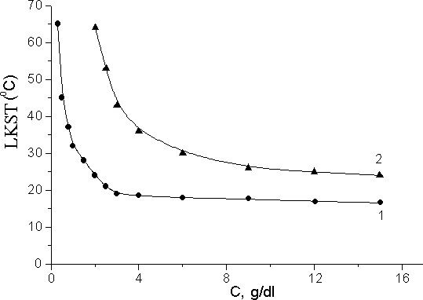

[HEA]:[HEMA], mol%: 1 – 91.3:8.7; 2 – 81.5:18.5.

Fig. 1. Dependence of LCST of HEA-HEMA copolymers on the temperature in aqueous solutions. Table 1. Characteristics of HEA-HEMA copolymers

|  |  |  |  |  |
| --- | --- | --- | --- | --- |
| [HEA]:[HEMA],  mol% in initial | [HEA]:[HEMA],  mol% in | Mn | Mw | Polydis-  persion |
| monomer mixture | copolymer |  |  | degree |
| 90:10 | 91.3:8.7 | 1,67106 | 2,79106 | 1,66 |
| 80:20 | 81.5:18.5 | 2,73106 | 3,14106 | 1,15 |
| 70:30 | 71.7:28.3 | 2,75106 | 3,08106 | 1,12 |
| 60:40 | 60.8:39.2 | 2,95106 | 3,30106 | 1,12 |
| 50:50 | 50.2:49.8 | 3,23106 | 3,54106 | 1,09 |

It should be note HEA homopolymer is high hydrophilic and aqueous solutions of these homopolymer do not show LCST. Apparently, LCST of HEA-HEMA copolymers is caused by appearance of hydrophobic methyl groups of HEMA in copolymer structure. As shown in Fig. 1, linear HEA-HEMA copolymers have

phase temperature transition in the range 17-65 0C, depending on the monomer ratio: the higher the ratio of more hydrophobic HEMA, the lower the LCST.

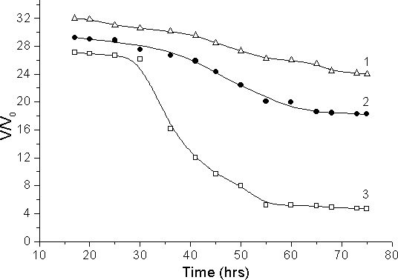The data obtained for linear copolymers correlate with data obtained for copolymer hydrogels. Dependence of synthesized copolymers swelling behavior on temperature is presented in Fig. 2. As it is seen, all samples undergo contraction with increasing temperature. For samples 1 and 2 (Fig. 2, curves 1, 2) that are more hydrophilic, contraction occurs not expressively. Hydrophobic interaction in their macromolecules is not strong enough due to a low content of hydrophobic methyl groups. In this case in order to cause the collapse of macromolecules the higher temperature should be applied. The total amplitude of hydrogels contraction in studied temperature range is significantly less than that for the sample 3 (Fig. 2, curve 3). It can be explained by the highest content of hydrophobic units and as a result the high amplitude of contraction with temperature increase was observed.

Copolymers [HEA]:[HEMA]., mol%: 1 – 91.3:8.7( sample V1); 2 – 81.5:18.5 (sample V2) ; 3 – 71.7:28.3 (sample V3) Fig. 2. Dependence of swelling ratio of HEA-HEMA hydrogels on the temperature in aqueous solutions.

* 1. *Interaction of copolymers with surfactants*

Thus, for a hydrogel to show impressive thermo-collapse, it should swell significantly in water and simultaneously have sufficiently high content of hydrophobic groups along its polymer backbone to provide strong hydrophobic interaction. As mentioned in the introduction, an interaction of non-ionic polymers contained hydrophobic moieties with ionic surfactants is a very effective method to increase solubility of the polymers due to electrostatic repulsion between likely charged surfactant's heads attached along the polymer backbone, while concentration of hydrophobic groups in copolymer composition remains to be high. Here this method was used to improve stimuli-sensitive properties of HEA-HEMA copolymers. Cationic cetyl pyridinium bromide (CPB) and anionic sodium dodecyl sulfate (SDS) were used as surfactants.

For investigation of interaction between HEA-HEMA hydrogels and surfactants, equilibrium swelled samples were moved from water into CPB and SDS solutions at fixed temperature of 20oC. Their swelling behavior was observed in course of interaction through measurement of their swelling ratio V/Vo (Fig. 3). HEA-HEMA hydrogels either swell or contract depending on surfactants concentration: if concentration of surfactants is sufficiently high (Fig. 3, curves 2, 3) then hydrogels swell else hydrogels contract (Fig. 3, curve 4). Because the mechanism of surfactant binding onto hydrophobically (if we will consider that HEMA is a hydrophobic comonomer) modified hydrogels is unknown and the complexity introduced by multiple interaction parameters (polymer-polymer; polymer-water; polymer-surfactant; water-water; water-surfactant; and surfactant-surfactant) in these multicomponent systems, the explanation for such behavior is at present tentative. We can note firstly that there is no presence of ionizable groups in chemical structure of hydrogels and therefore not any electrostatic repulsion in polymer structure. The observed influence of ionic surfactants SDS and CPB on HEA-HEMA hydrogels can be explained by assumption that ionization of gel is a result of surfactant molecules binding to the polymer network. It is obviously that within the gel phase the SDS joins to the polymer network by hydrophobic interactions. The SDS and CPB molecules consist of a long aliphatic

hydrocarbon chain and HEA-HEMA copolymers have hydrophobic methyl moieties as side groups. When SDS and CPB molecules diffuse into the gel network of copolymer, association should take place through the hydrophobic interaction between the methyl groups of hydrophobic comonomer and long chain alkyl groups of surfactants, thus increasing the surface charge density of hydrogels as the neutral polymers chains become polyelectrolytes.

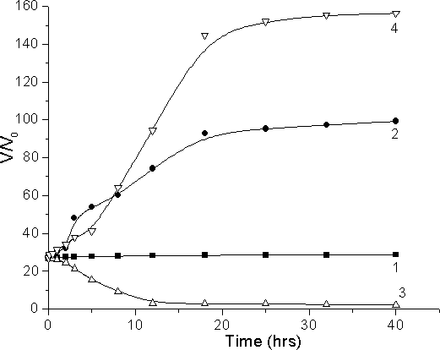

T = 200C, [HEA]:[HEMA] = 71.7:28.3 mol%, in [SDS], mol/L: 5*10-3 (1); 16*10-3 (2); in [CPB], 10-4 mol/L: 1*10-3 (3); 10*10-4 (4)

Fig. 3. Kinetics of swelling ratio changes of HEA-HEMA hydrogels in various concentration of surfactant solutions.

The presence of gained network charges and the counterions results in extra osmotic pressure on the network. In this case polymer conformation will shape more like an expanded coil than a globule and hydrogels swell. On the other hand at low concentration of surfactant such interaction leads to formation of additional junctions. It is caused by surfactant micelles formed in the hydrogel act as additional cross-linking aggregates, resulting in contraction of hydrogel. Domination of the one above mentioned of two factors leads to swelling behavior of copolymer hydrogels in surfactant solutions.

The HEA-HEMA hydrogel-surfactant polycomplexes were studied from their thermo-sensitive properties point of view in terms of swelling ratio versus temperature (Fig. 4). As seen from fig. 4, for polycomplexes, obtained by interaction of hydrogels with high concentrated aqueous solutions of CPB amplitude of contraction is great. But for slightly hydrophobic sample (Fig. 5, curve 1) the contraction is not expressed, while the sample with the highest content of hydrophobic component (Fig. 4 curve 3) undergoes strongly pronounced collapse with extremely high amplitude, what was not observed for the initial hydrogels of any composition (Fig. 1).

The highest degree of swelling ratio which has been achieved for HEA-HEMA hydrogels varying synthesis conditions in wide range, was 32, whereas hydrogels modified with CPB demonstrate value of V/V0 at room temperature close to 156. It should be noted that a certain shift in temperature interval of collapse to a higher range observed at the exception of significant increase of amplitude and narrow temperature interval of collapse.

Obviously, the presence of ionic heads of the surfactant increases the network hydrophilicity while the presence of hydrophobic tails of the surfactant helps contraction of the modified network.

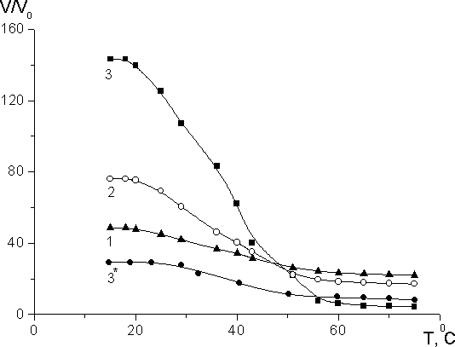

[CPB] = 1·10-3 mol/l

[HEA]: [HEMA], mol.% = 91.3:8.7(1); 81.5:18.5(2); 71.7:28.3 (3*)

3*- initial hydrogel of HEA-HEMA copolymer.

Fig. 4. Influence of temperature on swelling behavior of hydrogels complexes of HEMA-HEA copolymers with CPB.

Thereby in present work HEA-HEMA copolymers were prepared by free radical copolymerization and their physicochemical properties were investigated by NMR-, spectroscopy, gel permeation technique. The interaction of copolymers with surfactants was studied. It was observed that thermo-sensitive parameters of the water swelling copolymers HEA-HEMA after interaction with ionic CPB and SDS are greatly improved, and hydrogels treated by surfactant solutions undergo sharp thermo-induced collapse with high amplitude.

# References

1. Galaev I.Yu., Mattiasson B. Thermoreactive water-soluble polymers, nonionic surfactants, and hydrogels as reagents in biotechnology. Enzyme and Microbial Technology. 1993;15:354-366.
2. Peppas N.A. Hydrogels in medicine and pharmacy. Vol. 1: Fundamentals. Boca Raton, FL: CRS Press. 1986.
3. Langer R. Drug delivery and targeting. Nature. 1998;392:5.
4. Mun G.A., Nam I.K., Sarsengaliev R.R., Nurkeeva Z.S., Urkimbaeva P.I., Park K. Swelling behavior of amphiphilic hydrogels of copolymers of the vinyl ether of ethylene glycol and vinyl isobutyl ether, and their interaction with cationic surfactant. Colloid Polym Sci. 2004;282:1111-1117.
5. Hoffman A.S. Really smart bioconjugates of smart polymers and receptor proteins. J. Biomed. Mater. Res. 2000;52:577-586.
6. Safrany A. Synthesis and characterization of superclean thermo-reversible copolymer hydrogels. Radiat. Phys. Chem. 1999;55:121-126.
7. Khutoryanskaya O.V., Mayeva Z.A., Mun G.A., Khutoryanskiy V.V. Designing Temperature-Responsive Biocompatible Copolymers and Hydrogels based on 2-Hydroxyethyl(meth)acrylates. Biomacromolecules. 2008;9 (12):3353-3361.
8. Mun G.A., Nurkeeva Z.S., Beissegul A.B., Dubolazov A.V., Urkimbaeva P.I., Park K., Khutoryanskiy V.V. Temperature-Responsive Water-Soluble Copolymers Based on 2-Hydroxyethyl Acrylate and Butyl Acrylate // Macromol. Chem. Phys. – 2007. - V. 208, #9. - P. 979-987